**Single Source Shortest Path Lab Question**

For all the graphs, you have to create their corresponding text files.

1. Run Bellman Ford's algorithm on the following graphs and find out whether a negative cycle exists or not. Pick any node as the source.

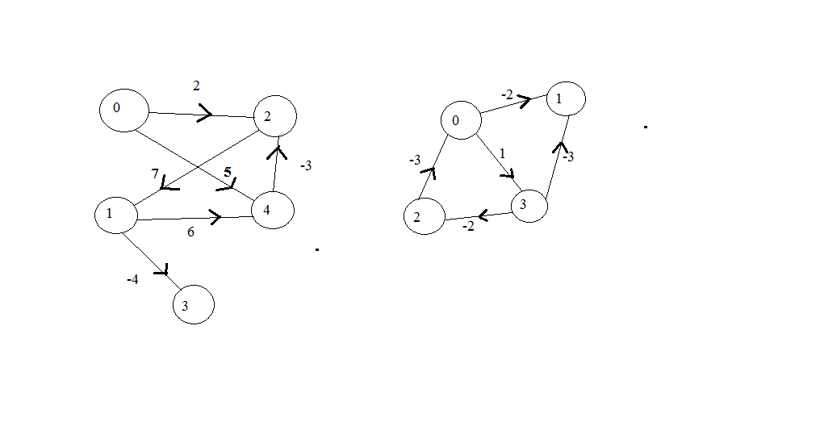

2. Run Dijkstra algorithm on the following graphs to find the shortest path and of course print them. The red node is the source.

